All el:U�"--1
rrevale,nce of· u:tritiomd IDefiiaie,nrie: arnong ,C·h1dre,n II d Wome11 . 1.ier 11d:on11J IF11111 I Heaflh Sur\it-V- 4 (2015-16)
:S.No | Smte |  | Clrlldi;e:n m111ler 5 |  | ·yean, |  | Wome,n (15-49 years)
 |  |  | Uiulerwei!!Jbt | :S:Wl[till,l:! |  | At111e,n1ill | Chronic  Ertergy  IDefie.iency | Arrn.emi11
I | A&N Maruk |  | 21.6, | 23,_3, |  | 49 | 13.1 | 65.1
1 | Alldhm Pradesh |  | 31.9 | 3,1.4 |  | 58.6 | 17.6 | 60
3 | Anmac.ha.1 P'rn.d�sJ:11 |  | 19.5 | 29.4 |  | Stl.7 | !t.s | 40.3
4 | Assam |  | 29J! | 3,6.4 |  | 3,5_7 | 25.7 | 46
5 | Bihar |  | 43.9 | 48-3. |  | 63,_5 | 3,0,_4 | 60.3
6 | Chandi;l!ath |  | 24.5 | 28.7 |  | 7H | 13.3 | 75.9
1 | Chh.attis�arh |  | 37.7 | 3,7_6 |  | 4U | 26.7 | 47
$. | D&N Haveli |  | 38.9 | 41.7 |  | 84.6 | 28.5 | 79..5
9 | Darnall.& Diu |  | 26.7 | 2H |  | U8 | 12.9 | 5$..9
10 | Delhi |  | 27 | 3,2_3, |  | 62.6 | 12.8 | 51 | ...5
II | Goa, |  | 23.8 | 2tl.l |  | 48-3 | 14.7 | 31.3
11 | Gujarat |  | 39.3 | 3.8.5 |  | 62.6 | 27.2 | 54.9
13 | Ha:rvana |  | 29.4 | 34 |  | 11.1 | 15.ll | 61 | ..1
14 | Himae'.hal Pradesh |  | 21.2 | 26-3 |  | 53,_7 | 16.2 | 53.4
15 | J&.K |  | 16.6 | 27.4 |  | 4B | 12.1 | 40.3
16 | Jbarllliand |  | 47.8 | 45_3, |  | 69.9 | 3,1_5 | 65.1
17 | Kai'i:'i.atak:a |  | 35.2 | 36-2 |  | 60.9 | 20.7 | 44.$.
1$. | K.erala |  | 16.1 | 19.7 |  | 3,5_6 | 9.7 | 34.1
19 | Lal::shdw·eep |  | 23.4 | 11 |  | 51.9 | 12.5 | 45.7
20 | Madhya Prad | .e.sh | 42Jl | 42 |  | 68.9 | 28.3 | 51 | ..5
21 | Maharashtra |  | 36 | 34.4 |  | 53.8 | 23.5 | 48
ll | Manii,ur |  | 13.8 | 28.9 |  | 23..9 | !ti! | 26.4
23 | Meo.hafova |  | 29 | 43,_g |  | 48 | 12.1 | 56.1
24 | Mizol'iMn |  | 11.9 | 1$. |  | 17.7 | 8.3 | ll | ..5
25 | Nap;aland |  | 16.8 | 28.6 |  | 2U | 12.2 | 23.9
26 | Ori:ssa |  | 34.4 | 34.l |  | 44.6 | 26.4 | 5[
11 | Pudud:terry |  | 22 | 23,.7 |  | 44.9 | 11.3 | 51..4
1$. | PUll,iab |  | 2'1.6 | 25.7 |  | SU | l 1.7 | 53.5
19 | Raja-siih.an |  | 36.'i' | 3,9_1 |  | 60-3 | 11 | 46.S.
30 | Si�im |  | 14.2 | 29.6 |  | SH | 6.4 | 34.9
31 | Tamil Nadu |  | 23.8 | 27.l |  | Stl.7 | 14.6, | 55.1
31 | TeJangana |  | 21!.5 | 28.l |  | 6tl.7 | 23.1 | 56.1
33 | Tritium |  | 24.1 | 24-3 |  | 48-3. | 18.9 | 54.5
34 | Uttar Pradesb |  | 39.5 | 46-3 |  | 63-2 | 25.3 | 51 | ..4
35 | Uttamli1.and |  | 26.6, | 3,3,_5 |  | 59.8 | 18.4 | 45.1
36 | \Vest Benµ;al |  | 3U | 3,2.5 |  | 54.2 | 21.3 | 61 | ...5
 | lndi11 |  | JS.7 | JIU |  | 5ilA | 22.9 | 53

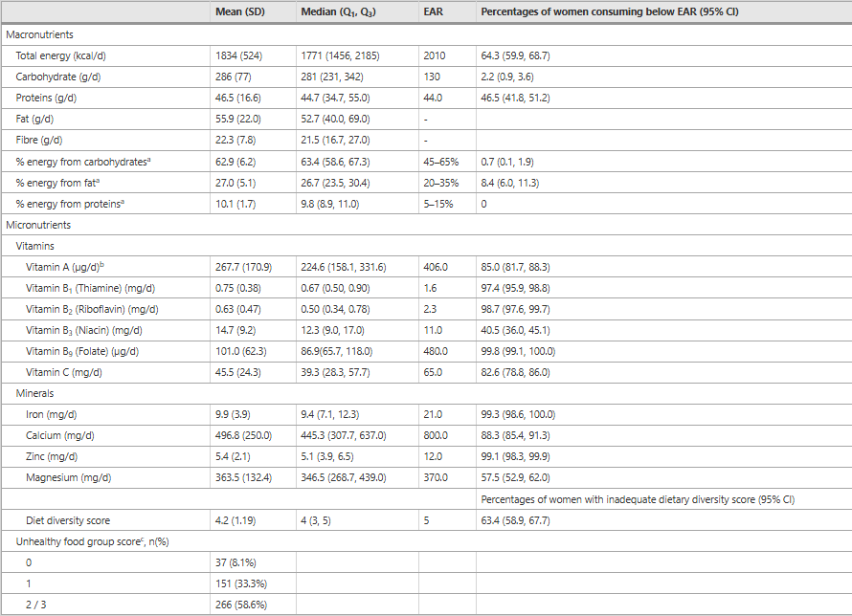

# | Deficiency | Description & Data | Main Causes
1. Iron Deficiency (Anaemia) | ⚠ Most prevalent deficiency.  NFHS-5 (2019–21) reports 57% of  women (15–49 years) are anaemic. Iron deficiency is the leading cause. | Low dietary iron, poor absorption due to high phytate diets, menstrual blood loss, and pregnancy demands.
2. Vitamin D Deficiency | Found in 70–90% of Indian women (ICMR studies, 2023). | Limited sunlight exposure, cultural clothing, low dietary intake of fortified foods.
3. Calcium Deficiency | Affects around 50–60% of women, especially  post-menopausal (National  Institute of Nutrition data). | Low milk consumption, poor dietary diversity, vitamin D deficiency.

4. Folate & Vitamin B12 Deficiency | Common among pregnant and reproductive-age women, leading to neural tube defects and fatigue. | Poor intake of green leafy vegetables, low animal product consumption.
5. Iodine Deficiency | Though largely reduced, around 13% of women still show inadequate iodine intake (India Iodine Survey, 2021). | Inadequate use of iodized salt, poor awareness in rural areas.

Policy / Programme | Year / Ministry | Focus / Interventions
POSHAN Abhiyaan (National Nutrition Mission) | Launched 2018 by MoWCD | Convergent approach to improve nutrition among children, pregnant and lactating women. Focuses on reducing anaemia, low birth weight, and stunting.
Anaemia Mukt Bharat (AMB) | 2018, Ministry of Health & Family Welfare | Targets 50% reduction in anaemia among women (15–49 years) by 2025. Promotes  iron-folic acid supplementation and deworming.
National Iron Plus Initiative (NIPI) | 2013, MoHFW | Provides iron and folic acid supplementation to children, adolescents, and women of reproductive age.
Mid-Day Meal & PM POSHAN Scheme | Revamped 2021 | Provides fortified meals to children and adolescent girls to improve iron, folate, and protein intake.
Food Fortification Program (FFRC – FSSAI) | Ongoing | Promotes fortification of staples — wheat flour, rice, milk, oil, and salt — with iron, folic acid, vitamin B12, and iodine.
Pradhan Mantri Matru Vandana Yojana (PMMVY) | 2017, MoWCD | Provides nutritional support and conditional cash transfer to pregnant and lactating women for better diet and rest.

